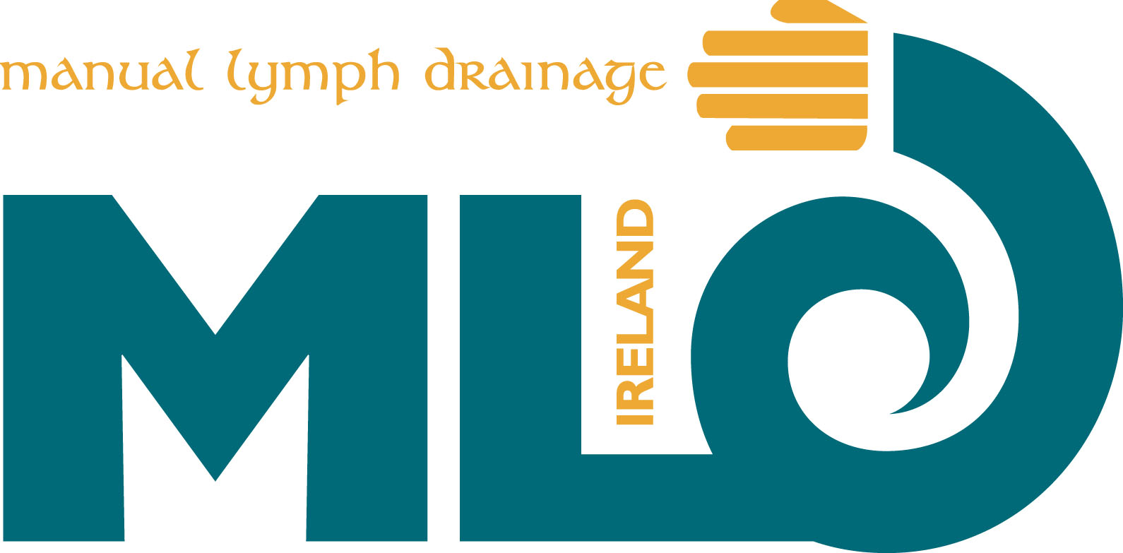
MLD Ireland AGM
Sunday May 26th 2013 1.30pm
Castletroy Park Hotel, Dublin Road, Limerick

Vice Chairs Report
I would like to thank the committee for their enthusiasm and hard work during the year and it has been a pleasure to work with them all.

Barbara has covered everything, but I would like to add that MLD Ireland is being added digitally to the Irish Medical Directory and to next year’s print edition. This gives us professional acknowledgment and should bring new business to our therapists.

Monica Conway
Vice-Chair
MLD Ireland

