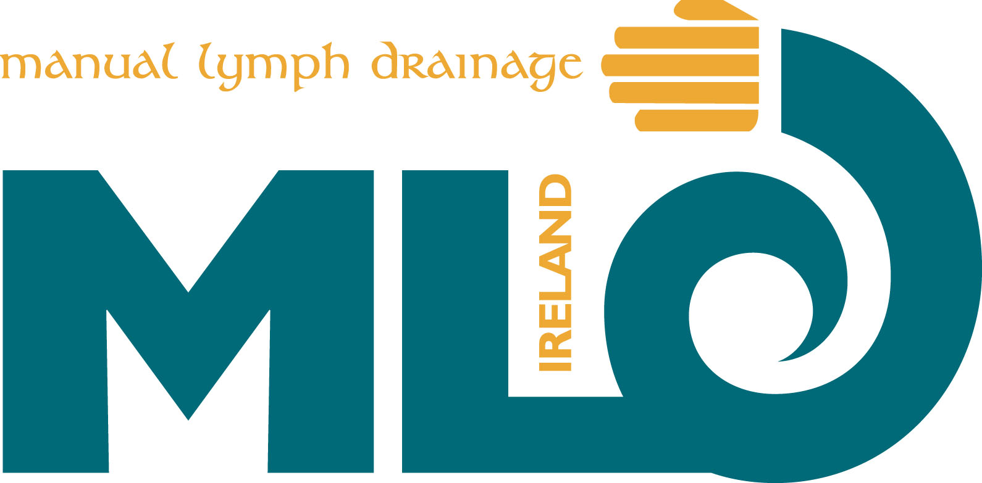
MLD Ireland AGM
Sunday May 26th 2013 1.30pm
Castletroy Park Hotel, Dublin Road, Limerick

Membership Report
The current economic climate places many challenges for organisations and their members. Many organisations during the past year have experienced difficulty in maintaining their traditional services to their members and maintaining their membership numbers. The committee took all of these challenges on board and during the past twelve months, there have been many exciting developments relating to membership.
- A member’s database was developed and includes a full and concise listing for each member. This database will generate emails to members reminding them 1 month prior to the expiry of their: Insurance, recertification and membership.
- The ‘Members Area’ on the MLD Ireland has been updated allows easy access for members details to be updated on the ‘Find a Therapist’ section of the new website and eases the administrative role of the membership secretary. The new member’s area also offers the facility to members to renew their own passwords, should they forget them, which greatly speeds up access.
- As a result of the updated listing of members on the website, our member’s listings are now being used and displayed on websites by NGO’s i.e. The Irish Cancer Society.
Membership Analytics
# | Membership Type | Total Members | Active Members | Inactive Members
1 | Full | 43 | 37 | 6
2 | Associate | 1 | 1 | 0

Summary:
10 MEMBERS are with us between 13 and 9 years = 1 quarter of our members (23%) this is standing for expertise and experience)
13 Members are with us between 7 and 4 years = ( 29%)
14 members are with us between 3 and 1 years = (32%)
5 new members = (11%)

MLD Ireland would like to welcome our new members:
Bernadette Pierce, Emma Bailey, Deidre Cullivan and Jennifer Kelly
We also have a further three new membership applications currently being process.
During the past twelve months, MLD Ireland has maintained it membership number and is on target to increase the membership figure over the next twelve months.

Meadbh MacSweeney
PRO
MLD Ireland

